
Test Case
Target point goal accepted for a ramp with less than 15 degrees
Robotic Cognition System for Wheelchair
Unicamp

Table of Contents
1 Purpose of this Document 3
2 Test case F: Target point goal accepted for a ramp with less than 15 degrees 4

Document Information
Project Name: | Robotic Cognition System for Wheelchairs
Prepared By: | Tarcisio Franco de Carvalho | Document Version No: | 1.0
Title: | Test case F – Target point goal accepted for a ramp with less than 15 degrees | Document Version Date: | 13/Oct/20
Reviewed By: |  | Review Date:
Distribution List
From | Date | Email

Acronyms
Acronym | Description

Document Version History
Version  Number | Version  Date | Revised By | Description
1.0 | 13/Oct/2020 | Tarcisio Franco | Initial Version

Purpose of this Document
Define and document the test cases related to the robot cognition system solution for wheelchair.

Test case F: Target point goal accepted for a ramp with less than 15 degrees

This test case will verify if the robot cognition system can classify a desired target point in a terrain with 15 degrees uphill as safe, considering that the wheelchair robot has climb capability up to 15 degrees.

Entry criteria
- Gazebo up and running the simple_blocks.world configuration
- Gazebo up and running the sim_model.urdf.xacro related to the wheelchair robot components
- Python web server up and running the web_app.py script
- Rviz up and running
- UPD processing component up and running
- Laser sensor data to point cloud parser component up and running
- Classify passage condition component up and running
- Move to target point component up and running

Exit criteria
- Target point classified as safe

Test execution and results

- Start Gazebo environment simulation
On the project root folder, run the script ./sim_model/scripts/launch.sh it will process the rcs_model_1.world and sim_model.urdf.xacro files

Result
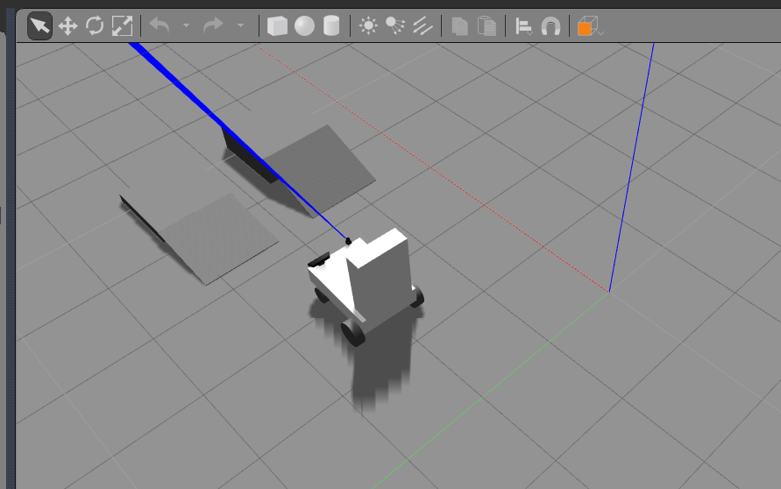

- Start web user interface to control the laser

On the project root folder, run the script python src/web_app.py it will start the flask web server and a web page where the laser can be controlled. After starting, in a web browser open the http://localhost:8080

Result
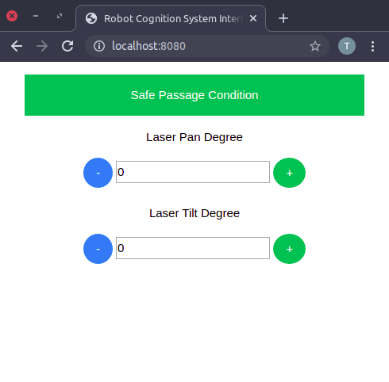

- Start the laser sensor data to point cloud parser component

On the project root folder, run the script python src/laser_publisher.py it will start a node to published parsed laser data.

Result
Passed. In the Rviz the red points are the parsed laser data
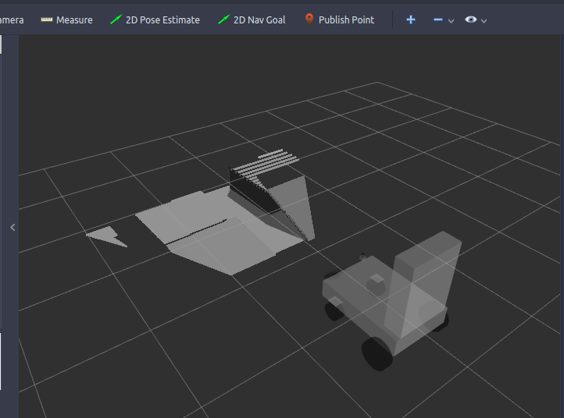

- Set 15 deg in UPD properties file and start the UPD processing component

- Set property UPD_DEG_ANGL to 15 deg
Open the file upd_run.sh and update the property UPD_DEG_ANGL

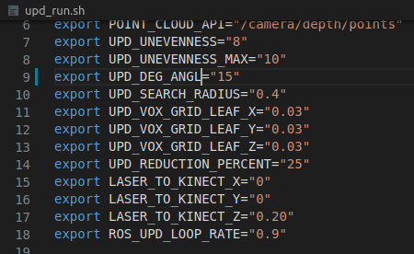

- On the project root folder, run the script ./upd_run.sh it will start a node to published UPD data

Result
Passed. In Rviz the UPD data is being showing.

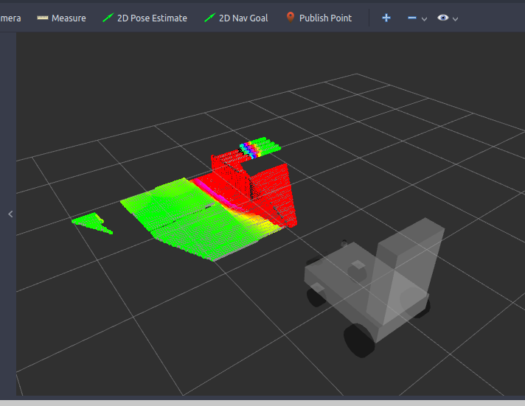

- Start the Classify passage condition component

On the project root folder, run the script ./classifier_run.sh it will start a node to publish passage condition classified data

Result
Passed.
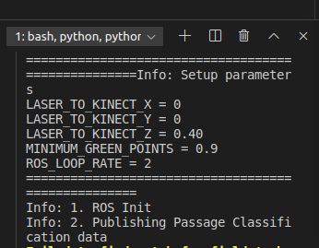

- Move the laser direction to the left ramp (This ramp has less than 15 degrees of slope)
In the UI, move the laser pan and tilt to reach the left ramp and check if the passage condition was classified as “safe” in the web interface

Result
Passed

Simulation | Rviz | UI
